CO2 emissions

# Introduction

This assignment regarding CO2 emissions aims to provide an answer to the following three questions:

1. What is the biggest predictor of a large CO2 output per capita of a country?
2. Which countries are making the biggest strides in decreasing CO2 output?
3. Which non-fossil fuel energy technology will have the best price in the future?

This report will follow above number structure to clearly outline what analysis has been performed to answer the specific question.

# Data and model

1. Data is obtained from the source below.

*Hannah Ritchie, Max Roser and Pablo Rosado (2020) - "CO₂ and Greenhouse Gas Emissions". Published online at OurWorldInData.org. Retrieved from: 'https://ourworldindata.org/co2-and-greenhouse-gas-emissions' [Online Resource]*

This dataset is a collection of key metrics on CO2 emissions, energy mix and other relevant metrics around this topic reported per year and by country.

The data analysis ran a correlation test between the metric CO2_per_capita and all other variables in the dataset. Whereas a value of 1 indicates a perfect positive correlation and a value of -1 the opposite. Furthermore the statistical significance is tested by running a Pearson R test.

2. Data is obtained from the same data source as used for Question 1.

The data analysis calculated the absolute and relative change in CO2 per capita per country. For the absolute change this is calculated by the following formula:

Last year CO2 per capita – first year CO2 per capita

For the relative change this formula has been used:

(Last year CO2 per capita – first year CO2 per capita)/ first year CO2 per capita *100

3. Data is obtained from source below.

*Hannah Ritchie, Max Roser and Pablo Rosado (2020) - "Levelized cost of energy". Published online at OurWorldInData.org. Retrieved from: 'https://ourworldindata.org/co2-and-greenhouse-gas-emissions' [Online Resource]*

This dataset includes the prices per year and per country for sustainable sources of energy.

To answer question three a linear regression model has been performed to predict future energy prices. This has been done by calculating the yearly average energy prices over all countries together to populate a historical price development.

# Results

1. The correlation result shows that energy consumed per capita is highly positive correlated with a CO2 output per capita. This is further illustrated in below scatterplot. The p-value is below <0.05 and therefore statistical significant.

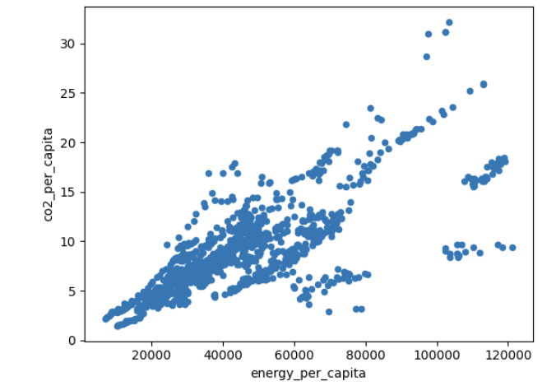

2. The results show two different top 3 countries with the largest CO2 emissions decrease per capita.

Top three countries absolute decrease:

1. Luxembourg
2. Estonia
3. Ukraine

Top three countries relative decrease:

1. Ukraine
2. Malta
3. Lithuania

Ukraine is indicated in both absolute as relative terms to have the biggest CO2 reduction.

3. The results show that most likely both sources related to solar energy are expected to be the cheapest sources of energy in 2030. If current trend continues the prices are expected to run close to zero in 2030.

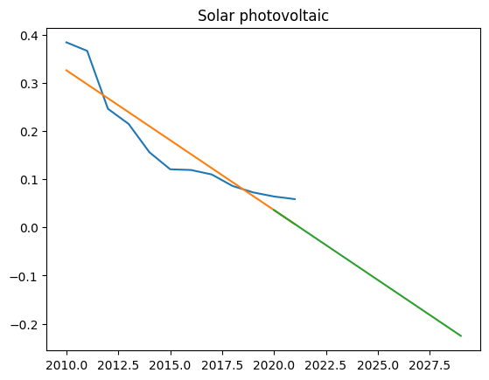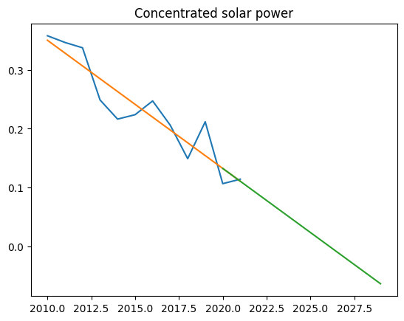

Conclusion

As a conclusion we can say that countries’ energy consumption has a high impact on CO2 emissions. The countries that show the largest decrease over the past decades are typically not the biggest world economies. Therefore it is import to reinforce that bigger countries are also actively striving to decrease their CO2 footprint by using alternate sources of energy. This research shows that especially energy coming from solar might provide an interesting alternative from traditional sources such as oil and gas.

Discussion

Please find enclosed the technical report where the data and results as described in this report are shown.